Jeppe High School for Boys

Subject: Life Orientation
Mid-Year Examination
Grade: 11

Date: 08 June 2018
Duration: 1 ½ Hours
Total Marks: 80
Examiner: B. Riskowitz
Moderators: T. Janse van Rensburg / S. McBride
QC Moderator: C. Rattray
Number of Pages: 9
________________________________
Instructions:
- Complete the front cover of your answer booklet.
- Answer all questions in the answer booklet provided.
- Answer all questions in Sections A and B.
- Answer 2 questions from Section C.
- Write your teacher’s name on the front cover.
- Number in the middle of the page.
- Write neatly and legibly.
- Rule off after each section.
- No borrowing.
- The following are not allowed in the examination room: cell phones, school bags, ipods (or similar devices), books, dictionaries, notes, sketches or paper.
Only the official examination material distributed by the invigilator is allowed.

SECTION A: 20 Marks

QUESTION 1: Multiple Choice
Various options are provided as possible answers to the following questions. Choose the most correct answer and write only the letter (A-D) next to the question numbers 1.1 – 1.10 in the answer book. E.g. 1.6 B

1.1 What is the term used to describe the inner ability and attitude to keep on trying,
despite difficulty or delay in achieving success?
- Perseverance.
- Courage.
- Passion.
- Apathy.

1.2 What is the term used to describe a structured learning programme which gives
you the opportunity to work and earn an income while you study towards a
qualification?
- Apprenticeship.
- Internship.
- Scholarship.
- Learnership.

1.3 What is the name of the system that gives points for the marks that you get in
your NSC examinations to receive admission to a higher learning institution?
- Admission Points System.
- Admission Points Score.
- National Benchmark Tests.
- National Protocol Points.

1.4 ________________ farming methods are cruel to animals.
- Uncultured
- Nomadic
- Inhumane
- Agroforestry

1.5 A mandate is:
- a tender compiled by government.
- a rule or law by which people must abide.
- the power to act that voters give their leaders.
- a quality of responsible governance.
[5]

QUESTION 2: Short Questions
Answer the following questions in full sentences, paying close attention to the mark allocations:

2.1 Name THREE (3) reasons why it is important that your goals are aligned
and balanced with your priorities? (3)
2.2 Explain the difference between a short and a long term goal. (2)
2.3 Discuss the aim of SETAs. (2)
2.4 How often do the national and provincial elections take place in South
Africa? (1)
2.5 Identify TWO (2) democratic structures in South Africa. (2) [10]

QUESTION 3: Definitions
Define the following terms:

3.1 values (in terms of goal-setting). (1)
3.2 distance education. (1)
3.3 FET subjects (1)
3.4 discrimination (1)
3.5 lobbying. (1) [5]
SECTION A: 20 MARKS

SECTION B: 30 Marks

QUESTION 4: Cartoon Analysis
Study the cartoon below and answer the questions that follow:
Source: Anderson. 2018. http://txfellowship.blogspot.co.za/2018/03/from-inbox-mondays-suck.html

4.1 Critically analyse why social media has such a big impact on our
relationships. (2X2) (4)
4.2 Deduce the possible outcomes and consequences for future generations
in a world consumed by social media usage. (3X2) (6)
[10]
QUESTION 5: Scenario
Read the case study below and answer the questions that follow:
South Africa has a range of world-class Higher Educational Institutions (HEIs). Obtaining good qualifications, however, can be expensive and not everyone can afford to pay for them. The good news is that there are options for financial assistance to study further. This means that the gates of learning are not closed for students who can’t afford it. However, one must remember that financial assistance often comes with certain obligations.
Anonymous

5.1 Demonstrate your understanding of the various types of institutions one
could study at in South Africa, by first identifying them and then critically
analysing the differences between them. (3+3) (6)
5.2 Contrast and analyse bursaries and study loans as financial assistance options to
fund higher learning. (2X2) (4)
[10]

QUESTION 6: Case study
Read the case study below and answer the questions that follow:
Source: Mortlock. 2018. http://ewn.co.za/2018/04/16/nmb-council-to-review-public-participation-processes-after-disruptions
CAPE TOWN – The Nelson Mandela Bay council says they're reviewing the way public participation processes are done.
Four community meetings were disrupted last week.
Last Thursday night, a meeting in Colchester, where the budget and integrated development plan was to be discussed, descended into chaos.
Police had to be called in after a group of about 200 residents took to burning rubble outside the hall where the meeting was held, torched several cars and stoned vehicles passing on the N2 highway.
One man was arrested for public violence.
EFF regional caucus leader, Zilindile Vena, has denied that the party had anything to do with the violence.
Vena says that many residents have lost confidence in public participation processes, because it hasn't yielded any results when it comes to issues of land or housing.
“Part of the issues around housing and occupation is the fact that there’s no direction and people are starting to panic.”
Council Speaker Jonathan Lawack says that councillors are concerned about the disorderly meetings and fear that it could lead to an injury or worse.
“We’re looking at redesigning our programme for public participation. But we can’t expose councillors, officials and members of the public to this kind of malicious behaviour.”
Lawack says they've tried to explain to disgruntled residents that the land issue is a national government mandate and not one for the municipality.
(Edited by Shimoney Regter)

6.1 Apply your knowledge of democratic structures to show why you would
find “public participation” in a democracy, but not in a dictatorship. (1+1) (2)
6.2 Critically analyse some of the major flaws of public participation by
referring specifically to the above case study. (2X2) (4)
6.3 Produce a plan of action, which all South African citizens can follow to
ensure that they are involved in public participation in the correct manner. (2X2) (4) [10]

SECTION B: 30 MARKS

SECTION C: 30 Marks
Only answer TWO (2) of the THREE (3) following questions. Please read all instructions as these can affect your marks to some extent.

QUESTION 7
Examine the image below and answer the question that follows:
Source: pintrest.com. 2018. https://za.pinterest.com/pin/395472411006723023/?lp=true
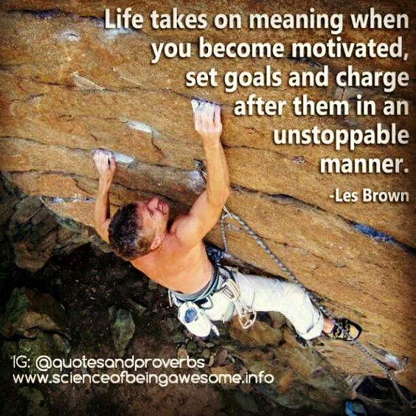

Construct an essay in which you:
7.1 Argue the importance of goals and values and explain how they relate to one
another.
7.2 Critique the SMART method of goal setting and evaluate its effectiveness.
7.3 Advise your fellow learners on how to effectively implement the following to ensure
success in setting their goals:
Perseverance.
Persistence.
Prioritising.
Passion.
Pride.
[15]
AND/OR

QUESTION 8
Compose an essay that addresses the following:
8.1 Justify why there is still a need for vocational courses and not just stringent
academic degrees.
8.2 Assess at least THREE (3) stigmas that are connected to vocational training and
formulate a solution for each of the mentioned stigmas.
8.3 Conclude with THREE (3) ways in which vocational training can combat
unemployment in South Africa.
[15]
AND/OR

QUESTION 9
Read the case study below and answer the question that follows:
Source: Modise. 2018. http://ewn.co.za/2018/04/23/kaizer-chiefs-to-probe-moses-mabhida-stadium-fan-violence
JOHANNESBURG – With two men expected to appear in the Durban magistrates court on Monday morning in connection with a riot at the Moses Mabhida Stadium, Kaizer Chiefs says its consulting the police and will also conduct its own investigation.
Soccer fans dressed in Chiefs regalia were seen vandalising parts of the stadium and storming onto the pitch after the team lost 2-0 to Free State Stars on Saturday.
A video has been making the rounds of a male security guard, initially thought to be a woman, being beaten by fans.
Seats were set on fire and TV cameras damaged.

Kaizer Chiefs’s Vino Maphosa says that while they will be launching a probe into the riot internally, the police are definitely investigating the assault of a security guard on the field.
“This matter has now transcended, it’s no longer a matter of football, it’s now a security, medical matter that has seriously become subject of an investigation.” (sic).
Meanwhile, the police’s Nqobile Gwala says the two men arrested have not been directly linked to the assault of the guard.
“At this stage the suspects were charged for public violence and malicious damage to property. The investigations are still continuing.”
Gwala says as police continue with investigations more arrests are expected.

Compile a magazine article which considers and answers the following:
9.1 Evaluate THREE (3) ways sport can detract from nation building.
9.2 Recommend THREE (3) strategies that could be implemented to prevent fan
violence at large sport events.
9.3 Choose a major sporting event which South Africa has hosted and appraise the
extent to which sport is an effective mechanism for nation building.
[15]

SECTION C: 30 MARKS
End of Paper
TOTAL: 80 MARKS

