bb

Jeppe High School for Boys

Subject: Life Orientation
Mid-Year Examination
Grade: 9

Date: 13 June 2018
Duration: 1 ½ Hours
Total Marks: 80
Examiner: J. De Lange
Moderators: B. Riskowitz
QC Moderator: C. Rattray
Number of Pages: 9
________________________________
Instructions:
- Complete the front cover of your answer booklet.
- Answer all questions in the answer booklet provided.
- Answer all questions in Sections A and B.
- Answer 2 questions from Section C.
- Write your teacher’s name on the front cover.
- Number in the middle of the page.
- Write neatly and legibly.
- Rule off after each section.
- No borrowing.
- The following are not allowed in the examination room: cell phones, school bags, ipods (or similar devices), books, dictionaries, notes, sketches or paper.
Only the official examination material distributed by the invigilator is allowed.

SECTION A: 15 Marks

QUESTION 1: Multiple Choice
Various options are provided as possible answers to the following questions. Choose the most correct answer and write only the letter (A-D) next to the question number 1.1 – 1.10 in the answer book. E.g. 1.6 B

1.1 On the 1 December, the world is encouraged to unite in order to show their support for members of their communities who have been affected or killed by a particular illness. This day is known as:
A. World Autism Awareness Day.
B. Workers’ Day.
C. World AIDS Day.
D. World Cancer Day.

1.2 The only way to determine your HIV status is by:
A. doing a blood test.
B. doing a urine test.
C. doing a saliva test that specifically tests for HIV antibodies.
D. both A and C.

1.3 Section 13 in the Bill of Rights states that:
A. no one may be subjected to slavery or forced labour.
B. no one may be treated unfairly.
C. all employees have the right to fair dismissal.
D. all employees are entitled to 21 days annual leave.

1.4 Reports show that teenage fathers:
A. are frustrated with themselves.
B. struggled to find work.
C. are unable to support their children financially.
D. all of the above.

1.5 South Africa is considered to be a:
A. republic state.
B. democratic state.
C. monarchy.
D. government state.
[5]

QUESTION 2: True or False
Indicate whether the following statements are TRUE or FALSE. Choose the answer and write only ‘true’ or ‘false’ next to the question number. Write the correct statement if the statement is FALSE.

2.1 FET is an acronym for Future Education and Tuition.
2.2 There are more than 15 types of sexually transmitted infection.
2.3 A contraceptive is a drug used to prevent men from developing sperm.
2.4 Equality means everyone is allowed to discriminate against everyone else.
2.5 Negative role models struggle to live by their values and are passive.
[5]

QUESTION 3: Match the Dates
Match the following public holidays with their correct dates. Write only the letter (A-E) next to the question number 3.1 - 3.5 in the answer book. E.G. 3.6 C.

3.1 1 May
3.2 25 May
3.3 16 June
3.4 27 April
3.5 16 December

A. Workers Day
B. Youth Day
C. Heritage day
D. Africa Day
E. Human Rights Day
F. Reconciliation Day
G. Freedom Day

[5]

SECTION A: 15 MARKS

SECTION B: 25 Marks

QUESTION 4: Cartoon Analysis
Analyse the cartoon below by answering the questions that follow:
Source: Martin. 2016. https://www.psychologytoday.com/us/blog/how-we-do-it/201605/summertime-sex-and-springtime-babies
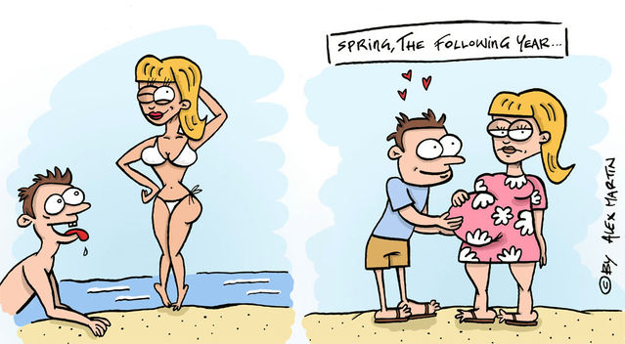
4.1 Discuss THREE (3) factors that could influence the personal behaviour
of teenagers and could lead to teenage pregnancy. (3X2) (6)
4.2 Critically discuss TWO(2) negative consequences the teenage girl in the cartoon
might face as a result of her early pregnancy. (2)
4.3 Discuss TWO (2) disadvantages faced by children born to teenage parents. (2)
[10]

QUESTION 5: Cartoon analysis
Consider the Zapiro cartoon published in 2012 (www.zapiro.com). Answer the questions that follow:
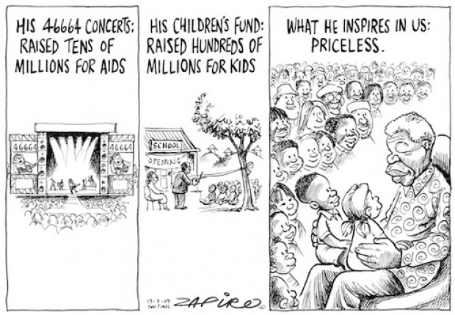

5.1 Nelson Mandela Day is celebrated on 18 July every year:
5.1.1 What happens on this day? (2)
5.1.2 How does this day honour and continue the priceless legacy of Nelson
Mandela? (2)
5.2. To many, Nelson Mandela is regarded as a positive role model whose
example should be followed:
5.2.1 Discuss TWO (2) reasons why Nelson Mandela is regarded as a
positive role model. (4)
5.2.2 Why do you think Nelson Mandela invested so much in the youth of
South Africa? Mention TWO (2) valid points. (2)
5.3 Consider the following: “His 46664 concerts raised tens of millions for
AIDS”.
5.3.1 What does the acronym AIDS stand for? (1)
5.3.2 What colour ribbon is associated with HIV/AIDS awareness? (1)
5.3.3.1 Which human right is violated by the stigma associated with AIDS? (1)
5.3.3.2 Provide TWO (2) examples that demarcate this. (2)
[15]
SECTION B: 25 MARKS

SECTION C: 30 Marks
Only answer TWO (2) of the THREE (3) following questions. Please read all instructions as these can affect your marks to some extent.

QUESTION 6
Analyse the cartoon below and answer the question that follows:
Source: Karsten, 2015. https://www.cartoonstock.com/cartoonview.asp?catref=kscn4481
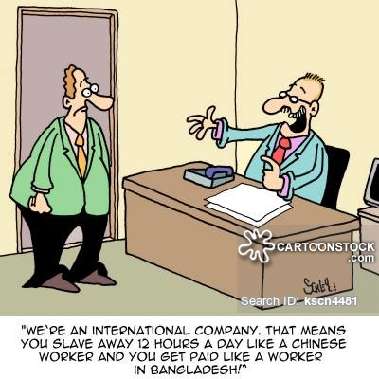

Construct an essay about rights and responsibilities of employees in the workplace.
In your essay:
6.1 Discuss the difference between acts and laws.
6.2 List one basic rights that is stated on our Bill of rights
6.3 Critically analyse how the following acts impact on the rights and responsibilities of
workers:
- The Employment Equity Act.
- The Basic Conditions of Employment Act.
- The Labour Relations Act.
6.4 Briefly evaluate the role of the CCMA.
6.5 Discuss ONE (1) benefit to workers from each of the following acts:
- Basic Conditions of Employment Act.
- Skills Development Act.
[15]
AND/OR

QUESTION 7
Analyse the cartoon below and answer the question that follows:
Source: Margulies, 2008. www.northjersey.com/margulies
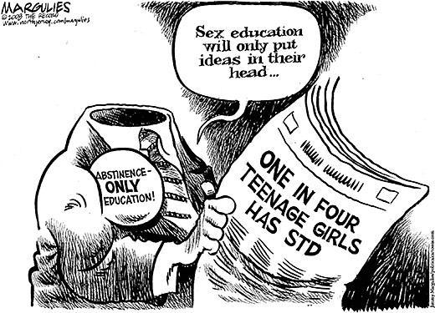

Consider the cartoon above, which illustrates differing attitudes towards sex education
at school. This cartoon raises the issue of which programmes are best for preventing
students from contracting STDs: 1. abstinence only programmes; or 2. programmes where
information is given about how students can protect themselves against contracting an
STD. Compose an essay which addresses the following:

7.1 State what ‘STD’ stands for and name TWO (2) ways in which a person can
contract an STD?
7.2 Of the two approaches: (1. abstinence only programmes; or 2. programmes where
information is given about how students can protect themselves against contracting
an STD), which approach do you think is the most effective and why?
7.3 Discuss TWO (2) different ways schools can prevent the spread of STDs amongst
learners and how a person is able to protect themselves from contracting an STD.
7.4 Discuss TWO (2) risk factors that could result in you contracting an STD, and
provide and example for each factor.
[15]
AND/OR

QUESTION 8
Study the extract taken from the Bill of Responsibilities for the Youth of South Africa published by the Department of Education in 2008:
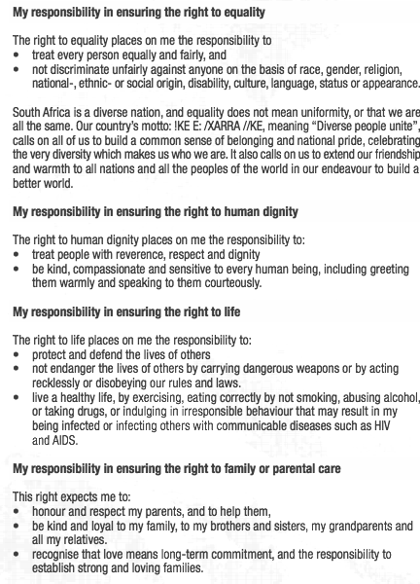
Produce an essay addressing the following aspects:
8.1 Explain your understanding of the statement: with rights comes responsibility.
8.2 The Bill of Rights also stipulates the right to property. Discuss THREE (3)
responsibilities in ensuring that right.
8.3 How does the current gang violence in schools violate an individual’s right to
education?
8.4 In light of the responsibilities identified above, how can the learners, the school, and
parents of learners, prevent gang violence from continuing in schools?
8.5 List THREE (3) responsibilities when ensuring the right to live in a safe environment.
8.6 Discuss your responsibilities in ensuring the right to citizenship.
[15]
SECTION C: 30 MARKS

End of Paper
TOTAL: 70 MARKS

